What we have done and screenshots

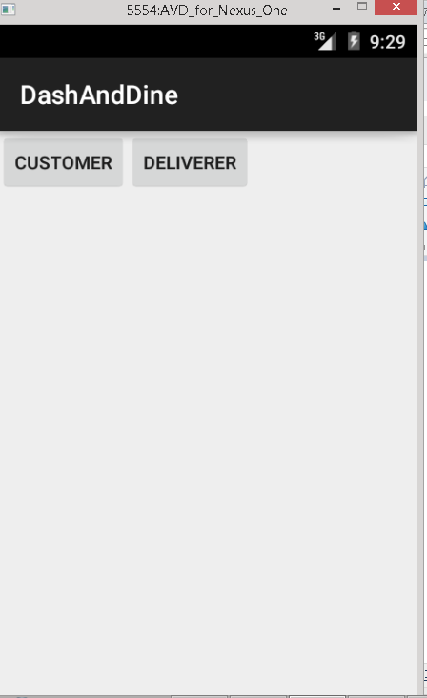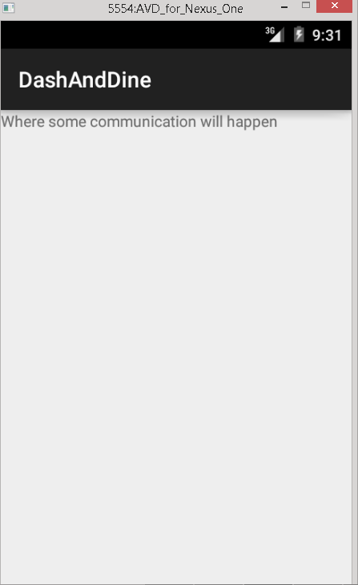

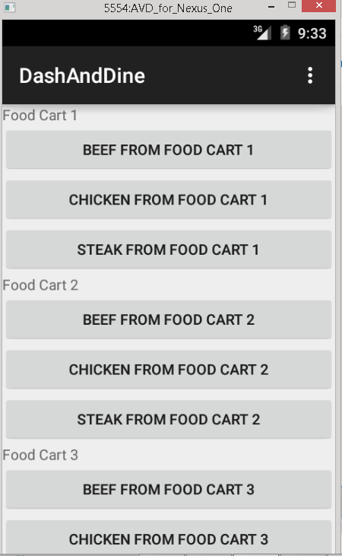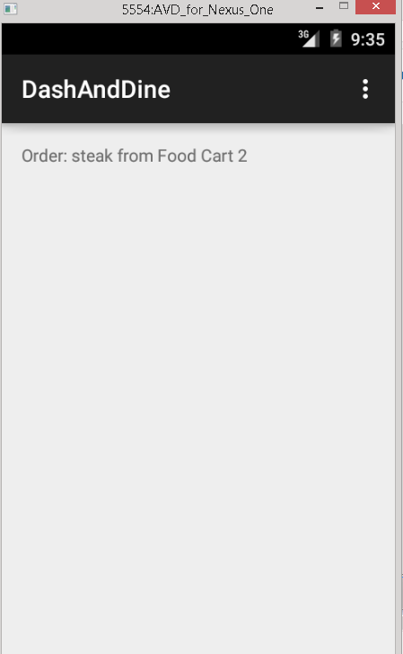

What we need to do and who’s doing it

* Incorporate a few food trucks, mock menus and a way to differentiate between deliverer and the person whose ordering
  + *Assigned to Mike Luker*
* Incorporate Maps API to track the location of the deliverer and the person ordering it
  + *Assigned to Eric Saputa*
* Incorporate system for the person ordering to contact the deliverer and communicate
  + *Assigned to Tiffany Wong*